University of Pittsburgh at Johnstown
Department of Electrical and Computer Engineering
EE 1195 / COE 1195 Engineering Practice and Professional Development
Block Diagram

Cycle Statistic Tool

Date: November 3rd, 2020

Submitted By: Jacob Hoffman
Cody Klingler

Instructor: Professor Gabany
Project Description:
The Cycle Statistic Tool is a data recording device which will be attached to the frame of a bicycle. In this position, several electronic components may be used to record statistics about a user’s cycling trip. The Cycle Statistic Tool will transmit data to a companion application that is installed on a user’s smartphone. This application will utilize the collected information to provide records of a user’s cycling sessions in the form of graphs and charts that enable the user to improve their cycling skills. An appropriate microcontroller will be used as the primary board to connect all sensors and for operation of the device. A secondary microcontroller will be attached to the pedal shaft to wirelessly relay data from this position to the primary board. Live data will be displayed to the user by a display panel connected to the primary board. The entire device will require a casement which will be modeled and 3D-printed. This casement should be weather-proof and able to connect to the frame/handlebar of a bicycle universally.

Description of Components:
Primary Microcontroller
The primary microcontroller will be used as the primary board to connect all sensors and for operation of the device. To enable data transmission between both the microcontrollers and between the primary microcontroller and the user’s smartphone, the primary microcontroller will have built-in Bluetooth and Wi-Fi technology. Additionally, the microcontroller will have an inertial measurement unit (IMU) on-board which features a 3D digital accelerometer and a 3D digital gyroscope. This will be used for calculating velocity, incline, and the angular frequency of the pedals. The primary microcontroller will be attached to the main frame of the cycle.
Secondary Microcontroller
The secondary microcontroller will be attached to the pedal shaft to wirelessly relay data from this position to the primary board. To enable data transmission between both the microcontrollers, the secondary microcontroller will have built-in Bluetooth and Wi-Fi technology. The secondary microcontroller will be attached to the cycle’s pedal shaft.
Lithium-Ion Batteries
The lithium ion batteries will supplement power to both microcontrollers, as well as all the attached sensors and components.
Display
A built-in display will enable the user to view real-time statistics of an active cycling session. The information that will be displayed includes current velocity, distance travelled, average speed, incline angle, torque, gear-ratio, power output, pedals per minute (cadence), wind speed, wind direction, calories burned, and the current time. Since it will offer dramatically lower power consumption and improved visibility in direct sunlight compared to traditional displays, an eInk display panel will be used.
Button Switch
A button switch will be required to calibrate the strain gauges due to change in temperature.
GPS Module
A GPS module will be used in conjunction with the on-board IMU to accurately measure the instantaneous velocity. Additionally, the GPS module will be used to collect GPS location data, dynamic travel time, and overall trip length.
Wind Angle Fin
The wind angle fin refers to a component of the Cycle Statistic Tool composed of a continuous potentiometer, a large plastic fin attached to the rod of the continuous potentiometer, and a 2-axis stabilizer. The wind angle fin will be used to determine wind direction.

Anemometer
The constructed anemometer will be used to measure wind speed. The anemometer will be mounted in an unrestricted location at the front of the cycle. Whenever the anemometer is spun, a measurable voltage is created. This voltage will be proportional to the rotations per minute (RPM) of the anemometer.
Photoresistor
A photoresistor will be used to control the white LED. Depending on the surrounding light level, the photoresistor will turn the LED on or off.
White LED
The white LED controlled by the photoresistor will be mounted above the display. This LED will increase visibility of the display in low-light conditions.
Strain Gauges
The four strain gauge sensors will measure the torque being applied by the cyclist. Strain gauges are thin strips that change in resistance depending on the flex and sheer force of what they are applied to. The strain gauges will be attached to the secondary microcontroller.
IR Sensor
The infrared (IR) sensors will be used to measure the angular frequency of the cycle’s pedals and rear sprockets. Whenever there is a bright object close to the surface of the sensor, it outputs a measurable signal. A reflective strip will be placed at one point in front of the sensor’s path. Measuring angular frequency will enable the calculations for power, gear-ratio and cadence.
Mobile Application
The mobile application on the user’s smartphone will receive and store information from the primary microcontroller over bluetooth. The application will use this data to create cycling session entries that will be used to compare their trips with the best and average trips overall. The application will also allow the user to change the settings of the microcontroller, such as units displayed and the user weight used for calculations.

Hardware Block Diagram:

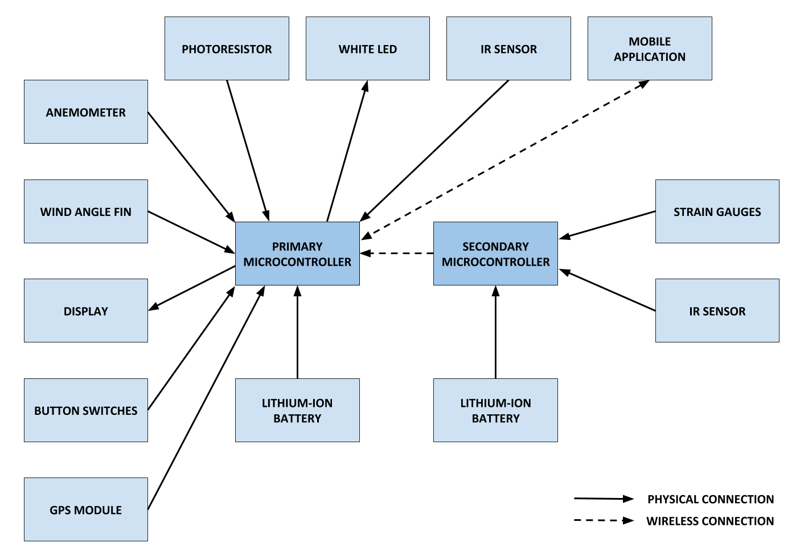

Software Flowchart:
